­

OCR Computer Science Project

H4406-03

Contents

Analysis

Problem Identification **Error! Bookmark not defined.**

Problem defenition 2

Stakeholders **Error! Bookmark not defined.**

The solution 4

Current solutions  4

Features 4

Limitations 4

Computational methods 4

Hardware and software requirements 4

Success criteria 4

Design 6

Structure 6

Decomposition 6

Key variables and structures 6

Algorithms 6

Usability features 6

Test data for development 6

Developing the solution 7

Testing 8

Evaluation 9

Appendix 10

Bibliography 11

# Analysis

Problem Identification

Currently there are no viable solutions for tracking multiple objects in one integrated platform. GPS and tracking technology allow users to track their assets with their precise and accurate location and more complex operations such as measuring speed and taking precise time measurements. Presently to track your holdings you must use different third-party platforms to tack individual devices with different operating systems which lack cross platform compatibility for viewing all assets location simultaneously. Furthermore, current solutions are only available for enterprises and lack the accessibility and customisability for smaller scale uses. Tracking an array of different devices in one platform would help many enterprises and companies and help reduce costs by investing in different tracking solutions for different platforms. This can also prevent assets from going unaccounted for and there could be notifications for when a device behaves abnormally.

This application is highly customizable and can be used in a wide range of situations for example: tracking a fleet of buses, tracking a endangered species dotted with a GPS tags sending signals to the server. Another example would be tracking family members or friends and using paths, alerts and statistics.

The solution would require a device with network connectivity and GPS to relay its position back to the server. The problem lends itself to a computational solution as it would entail interacting with a device. The solution, in in its primitive form, would track the object/ person using precise gps coordinates, then the software would map out its route and location and then send the information back to the server so others can view its location along with other objects. Also, I can aim to incorporate internet of things like individual objects that have sensors in to the software to cover a wide range of application for example tracking a fleet of trucks even for a home user tracking different home based appliances and providing a platform for the different devices to communicate with each other.

## Stakeholders

The clients and demographic for this application would have to include users of modern smart phones, laptops, tablets and devices connected to the internet,. Because of the range of users of handheld devices, the stakeholders will be a representative sample, from older users who struggle with technology, to younger people who are very familiar with handheld devices enabling them to be able to stress test the app under all circumstances,

The stakeholders for this application mostly casual users of mobile phones, but there are also people representing accessibility.

The stakeholder would need to add multiple assets to track and be able to test the performance of the application and if it displays multiple assets simultaneously.

The application would require a friendly user interface with large buttons and icons with larger text for users with older age or poor eyesight. Also, it can be customised for the benefit of each different user group.

The solution

Current Existing solutions

* Google Maps

Google Maps is a web mapping platform and consumer application offered by Google. It offers real time navigation, satellite imagery, aerial photography, street maps, 360° interactive panoramic views of streets (Street View), real-time traffic conditions, and route planning for traveling by foot, car, air, and public transportation. As of 2020, Google Maps was being used by over 1 billion people every month around the world.

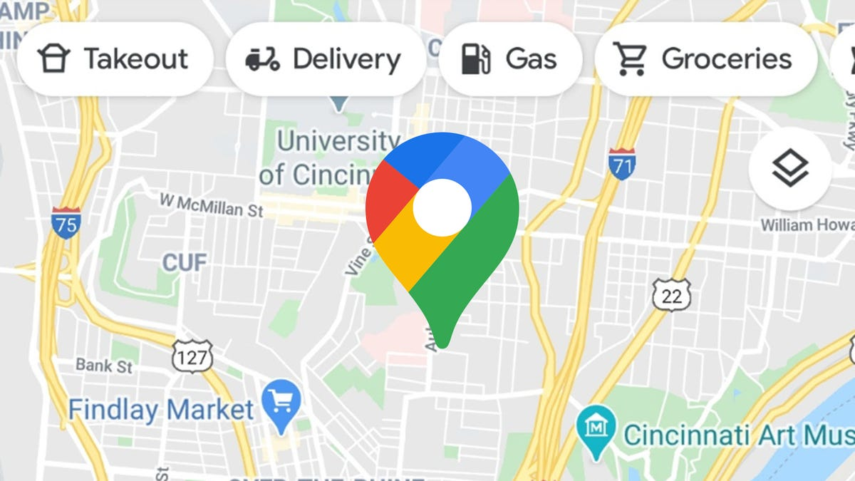

* Flight radar

Another example is Flightradar24 a Swedish internet-based service that shows real-time commercial aircraft flight tracking information on a map. It includes flight tracking information, origins and destinations, flight numbers, aircraft types, positions, altitudes, headings, and speeds. It can also show time-lapse replays of previous tracks and historical flight data by airline, aircraft, aircraft type, area, or airport.

* Uber

Uber Technologies, Inc., commonly known as Uber, is an American technology company. Its services include ride-hailing, food delivery (Uber Eats and Postmates), package delivery, couriers, freight transportation, and, through a partners hip with Lime, electric bicycle, and motorized scooter rental.

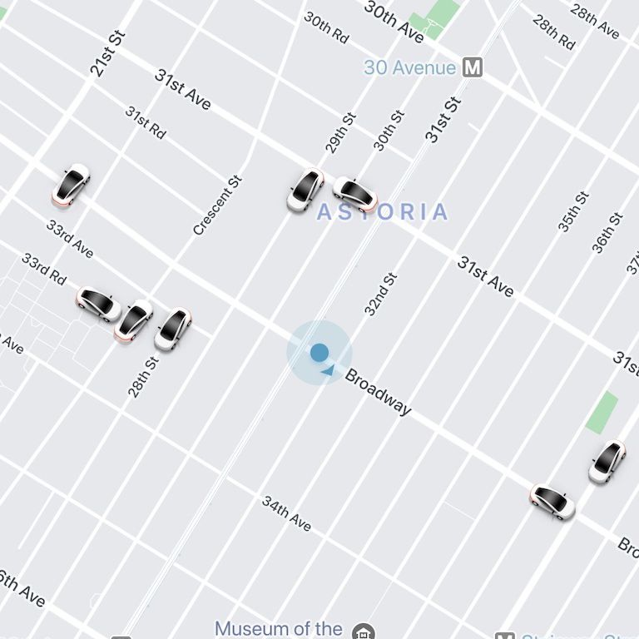

Design

Setting page

User profile

Logo

User interface

Home

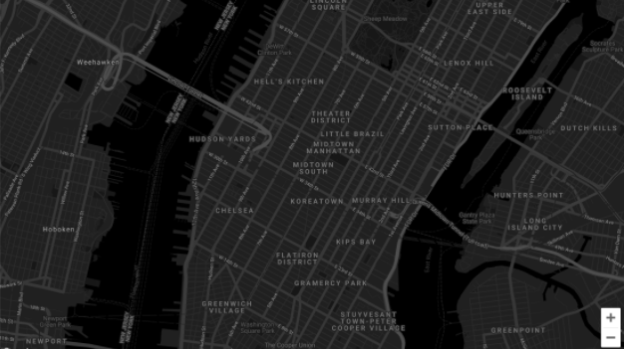

Buttons and drop down menus to customise map

Map displaying location

Analytics about device location gps coordinates device type speed

Sign in pop up

-sign in with google

-sign in with Facebook

-sign in with apple

-sign in with twitter

Home

Analytics about device location gps coordinates device type speed

Buttons and drop down menus to customise map



This is the main design of the program which allows the user to create an account with a profile and add devices and then view location analytics for that device. The application also has user analytics and can also customise the colours of the application to better suit the users’ needs and also the text size and the buttons size.

My application

Assets

Internet

User interface

Google maps API

Frontend: JavaScript/React

Backend : Node JS

Database : Firebase

### Existing solutions

## Features of the solution

### Features

### Limitations

## Computational methods

## Hardware and software requirements

## Success criteria

# Design

## Structure

## Decomposition

## Key variables and structures

## Algorithms

## Usability features

## Test data for development

# Developing the solution

# Testing

# Evaluation

# Appendix

# Bibliography